Stakeholder and Problem Analysis
Stakeholder Profile
Big Brother Student Accommodations is a student accommodation provider owned by Mr Ngubane. The organisation provides NSFAS-accredited accommodation to students which are mainly located in the Universitas area in Bloemfontein. They house CUT and UFS students but mostly UFS students since they are closer to their campus, but a shuttle service is available for CUT students or for when students want to go do groceries and other errands.
The stakeholder explained that the organisation currently relies mainly on word-of-mouth advertising, WhatsApp groups, current students, group administrators, and taxi associations to reach prospective tenants.
Current Process
The current accommodation process operates as follows:
- Big Brother Student Accommodations advertises its accommodation through word of mouth, WhatsApp groups, current students living there, group administrators of the shuttle service taking students to their hometowns when schools close.
- Prospective students make enquiries through these informal communication channels.
- Students are encouraged to visit the accommodation in person for a viewing.
- During the viewing, the owner explains the available facilities and accommodation arrangements.
- The student decides whether the accommodation is suitable.
- Bookings and payments are currently handled manually because the organisation does not have a formal management system.
- Management keeps information such as available units, room furniture, student details, deposits, and breakages manually.
People Involved
- Accommodation owner and management: Advertises the accommodation, explains the facilities, manages student information, and controls applications and bookings.
- Current students living there: Help advertise the accommodation to prospective tenants.
- Taxi association shuttle organisers: Help promote the accommodation to students travelling to the university at the start of each academic year.
- Shuttle group administrators: Share accommodation information with potential tenants.
- Prospective tenants: View the accommodation, submit their details, apply, and make booking decisions.

Affected Users
- Prospective tenants, especially first-year students, are affected by limited access to accommodation information and the risk of being misled by people falsely offering accommodation assistance.
- Accommodation owner and management are affected by limited marketing reach, manual booking and payment processes, and difficulty managing student and room information.
Problem Statement
Big Brother Student Accommodations currently relies on informal advertising methods such as word of mouth, WhatsApp groups, and taxi association promotion. Prospective students generally need to visit the accommodation physically to view the rooms and receive information. Bookings and payments are also managed manually because the organisation does not have a central management system.
This process makes it difficult for the organisation to reach enough prospective students, share accurate accommodation information, manage applications, and monitor available units. The stakeholder also reported concerns about first-year students being targeted by people falsely claiming to assist with accommodation arrangements. Management does not currently have a central system for managing student information, deposits, room occupancy, furniture, and breakages.
Consequences
The current process may result in:
- Limited reach to prospective tenants
- Difficulty sharing accommodation information
- Delays in managing applications and bookings
- Inconsistent or incomplete records
- Difficulty tracking room availability and student occupancy
- Increased exposure of students to accommodation scams
- A possible threat to the organisation’s business continuity
Need for Improvement
The organisation needs a centralised system that makes accommodation information easier to access, allows prospective tenants to view availability and apply, and helps management control, monitor, and respond to student information. The system should also protect student information and support more effective marketing of the accommodation.

Stakeholder and Problem Summary Table:
Question | Your answer
Who is the stakeholder? | The stakeholder is Mr Ngubane, the owner of Big Brother Student Accommodations, a student accommodation provider in the Universitas area of Bloemfontein.
What is the current process? | Accommodation is advertised mainly through word of mouth, WhatsApp groups, current students, shuttle-group administrators, and taxi association organisers. Prospective students enquire, visit the accommodation for a viewing, receive information about the facilities, and decide whether it is suitable. Bookings, payments, room availability, student details, deposits, furniture, and breakages are currently managed manually.
What is the main problem? | The organisation has limited reach to prospective tenants and no central system for sharing accommodation information or managing applications, bookings, payments, room availability, and student records. The stakeholder also reported concerns about students being targeted by accommodation scammers.
Who is affected? | Prospective tenants, especially first-year students, are affected by limited access to reliable accommodation information and possible scams. The owner and management are affected by limited marketing reach and manual record-keeping. Current students and shuttle-group administrators are also involved because they help advertise the accommodation.
What are the consequences? | The organisation may struggle to reach enough students, share accurate information, process applications efficiently, track room occupancy and availability, and maintain complete records. Students may have difficulty accessing accommodation information and may be exposed to misleading accommodation offers. These challenges may threaten business continuity.
What could the mobile application allow customers to do? | Prospective tenants could view the organisation’s information, available accommodation, room details, facilities, and availability; submit their personal particulars; apply for accommodation; make or request a booking; and receive application-status updates.
What could the web application allow staff to do? | Management could add and update accommodation information, manage available units and room details, view student and application information, review applications, respond to prospective tenants, monitor bookings, and manage relevant records.
What should be excluded from the project? | To keep the semester prototype manageable, exclude full payment-gateway integration, automated contract signing, advanced analytics, complex document verification, and multi-property expansion unless the stakeholder confirms that one of these is essential. Payment processing may be demonstrated using simulated payment-status data.

Scope element | Your answer
Project title | Big Brother Student Accommodation Management System Prototype
Aim | Develop an integrated Flutter mobile application and ASP.NET web application, supported by Supabase, to make accommodation information, applications, bookings, and management easier to handle.
Objective | Allow prospective tenants to view accommodation and availability, submit applications or booking requests, and receive status updates; allow management to manage listings, applications, bookings, and student records.
Deliverable | A Flutter mobile prototype, an ASP.NET web prototype, a shared Supabase database/integration, and supporting project documentation.
Acceptance criterion | Accommodation and application information submitted through the Flutter app must be stored in Supabase and visible for management to review through the ASP.NET web application.
Exclusion | Full online payment-gateway integration, automated contract signing, advanced analytics, complex document verification, and multi-property expansion unless the stakeholder confirms that one is essential.
Constraint | The prototype must be completed within one semester using the group’s available time, skills, equipment, and free or low-cost development resources.
Assumption | The stakeholder will provide accurate accommodation information and be available for selected feedback meetings. Test data will be used instead of real student personal information.
Short Scope: Big Brother Student Accommodations

Organised Findings table:
Heading | What was recorded for Big Brother Student Accommodations
Current process | Advertising through word of mouth, WhatsApp groups, current students, shuttle-group administrators, and taxi association organisers; student enquiry; physical viewing; explanation of facilities; student decision; manual bookings, payments, and record-keeping.
Main problems | Limited reach to prospective tenants, difficulty sharing accommodation information, physical-access barriers to viewing, manual records, and exposure of first-year students to accommodation scams.
Intended users | Prospective tenants/students and accommodation management.
Flutter functions | View organisation information, accommodation listings, room details, facilities and availability; submit particulars; apply or request a booking; receive status updates.
ASP.NET functions | Manage listings and availability; view and manage student details and applications; review applications; manage bookings and relevant accommodation records.
Shared information | Available units, room furniture, occupied rooms, student particulars, applications, bookings, deposits, and breakages.
Access needs | Students may view and update their own submitted information. Authorised management may view and manage applications, bookings, accommodation records, and sensitive student information.
Reports | Summary of page and accommodation views, student reviews/comments, and suggested areas for improvement.
Priorities | Easy access to accommodation information, effective marketing, online applications, application/booking status, and payment support. Full payment processing should be confirmed or simulated for the prototype.

Stakeholder Interview
Interview details
Organisation: Big Brother Student Accommodations
Stakeholder / Role: Mr Ngubane Student Accommodation Owner
Interview date: 25 August 2026
Interview method/location: In-person at Whitehouse Car Wash
Facilitator: NL Mazibuko, AL Hadebe
Note-taker: NL Mazibuko
Timekeeper: NL Mazibuko, AL Hadebe, MN Dlamini, LW Simelane, NP Khotle,
PA Mabusela
Requirements checker: MN Dlamini

Role | Responsibility | Group member
Facilitator | Leads the interview | NL Mazibuko; AL Hadebe
Note-taker | Records the responses | NL Mazibuko
Timekeeper | Monitors the meeting time | NL Mazibuko, AL Hadebe, MN Dlamini, LW Simelane, NP Khotle,, PA Mabusela
Requirements checker | Summarises and confirms the needs | MN Dlamini
Interview Roles Table:

Requirement Types table:
Requirement type | Simple meaning | Big Brother example
Functional | What the system must do | Students must be able to view available accommodation and submit an application through the mobile application.
Non-functional | A quality, rule, or condition | Only authorised management users may view or change sensitive student information.
System | Required technology or environment | The mobile application must use Flutter, the web application must use ASP.NET, and shared data must use Supabase.
Integration | How system components exchange information | An application submitted through Flutter must be stored in Supabase and made available to management through the ASP.NET web application.

Question & Answers
A. Current process
1. Can you walk us through how accommodation is currently managed, from a student first enquiring about a room until the accommodation arrangement is completed?
Answer:
Process of enquiry to filling rooms: Students are encouraged to physically come and do the viewing of accommodation and all facilities offered by the accommodation are then explained to them, it will then depend on the students whether they are happy with the accommodation.

2. How do students currently find out which accommodation or rooms are available, and how do they make an enquiry, application or booking?
Answer:
Advertising is currently and mostly done by word of mouth, making use of student what’s up groups and advertising with the taxi association which bring students from home to the university.

3. Who participates in the process, and what does each person do?
Answer:
Current students are requested to advertise the accommodation to prospective tenants. Taxi organisers also expected to sell the business to students using transport. Group admins are also used to advertise our business.

4. What tools or methods do you currently use to manage accommodation information, applications, bookings, payments, communication and other related activities?
Answer:
Tools to manage bookings and payments is through manual system we currently don’t have a proper system in place.

B. Problems and consequences
5. What difficulties or problems do you experience with the current process?
Answer:
Difficulty comes with not being able to reach the intended number of students. Inaccessibility for students to view the accommodations. First year students become victim to scammers claiming to assist them with accommodation arrangements.

6. Which of these problems causes the most difficulty, and why?
Answer:
Difficulties are with sourcing students and easily sharing business information to prospective tenants.

7. How do these problems affect the accommodation organisation or staff?
Answer:
Such challenges become a threat to the existence or continuity of the business.

8. How do these problems affect students or other users?
Answer:
Students are targeted by people falsely claiming to assist with accommodation arrangements and are scammed in the process.

C. Users and mobile application needs
9. Which types of people should use the proposed mobile application, and what should each type of user be able to do?
Answer:
Prospective tenants should be able to use the application and management, students should be able to upload their particulars and apply on the system, and management should be able to control, monitor and manage data.

10. What information should students be able to view or submit through the mobile application?
Answer:
⁠They should view and have access to the entire processes and business model and operations.

11. What actions would you want students to perform through the mobile application, such as viewing availability, applying, booking, checking status or reporting an issue?
Answer:
Students should be able to understand a vision, values and mission of the organisation be able to view accommodations check availability, apply and make bookings and check status updates accordingly.
D. Web application / staff needs
12. Which staff or stakeholder users should use the web application, and what should they be able to do?
Answer:
⁠Students and management should be able to make use of the application, student must view check availability, apply and make bookings on the application. Management should be able to access information provided by prospective tenants analyse, respond and manage information accordingly.

13. What information should staff be able to view, add, update, approve, reject or manage through the web application?
Answer:
Management should be able to manage, control and use information provided by students during application process and respond appropriately

14. What information or reports would help you manage the accommodation process more effectively?
Answer:
A summary of students who visited the page and view accommodation, reviews and comments from students, areas of improvement recommended by students.
E. Information, access and security
15. What information needs to be recorded and kept about accommodation units, students,
applications, bookings, payments or maintenance issues?
Answer:
⁠Number of units available, furniture for each room, details of students occupying the rooms, deposit paid by students, breakages

16. Who should be allowed to view, add, change or delete different types of information?
Answer:
Students should be eligible to view, add and change information pertaining to them and accept, approved by management

17. Are there any privacy, security or confidentiality concerns that we need to consider when handling student or accommodation information?
Answer:
Student information should be secured and not accessible by any person.

F. Improvements and priorities
18. If the proposed system could improve only a few parts of the current process, which improvements would be most important to you?
Answer:
⁠Easy access to information and application for accommodation, payment system.

19. What would make you consider the prototype successful or useful?
Answer:
By ensuring effective marketing of the business.

20. Are there any important requirements, problems or situations we have not asked about that you think we should understand?
Answer:
Only after the system has been developed and implemented, I will be in a position to review

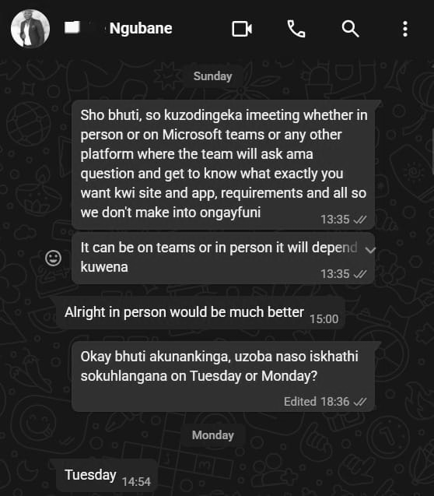
Evidence of stakeholder communication:
Figure 1 Stakeholder meeting confirmation
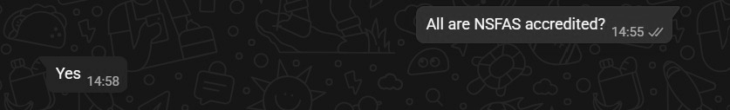
Figure 2 Are the accommodations NSFAS-accredited
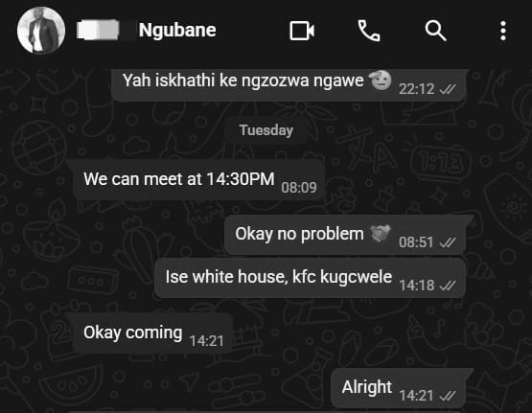
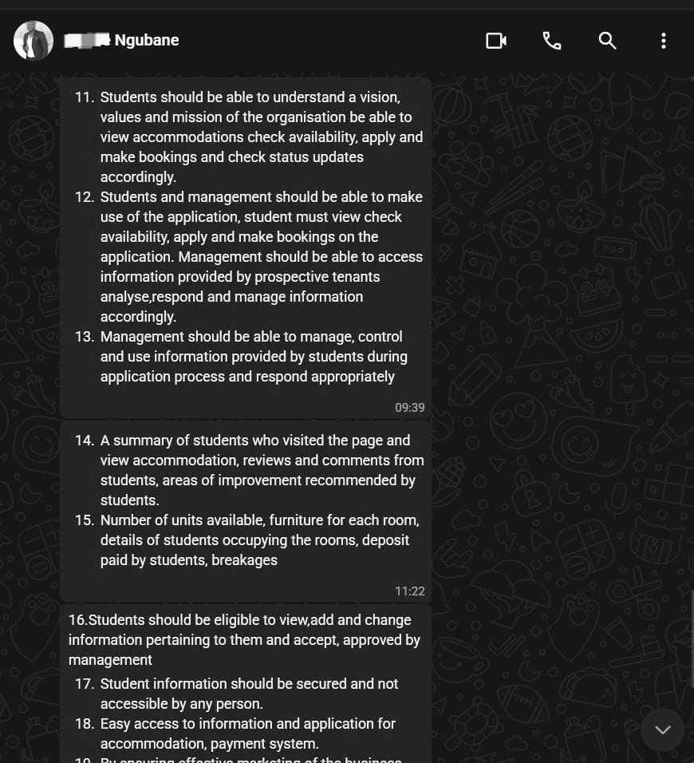
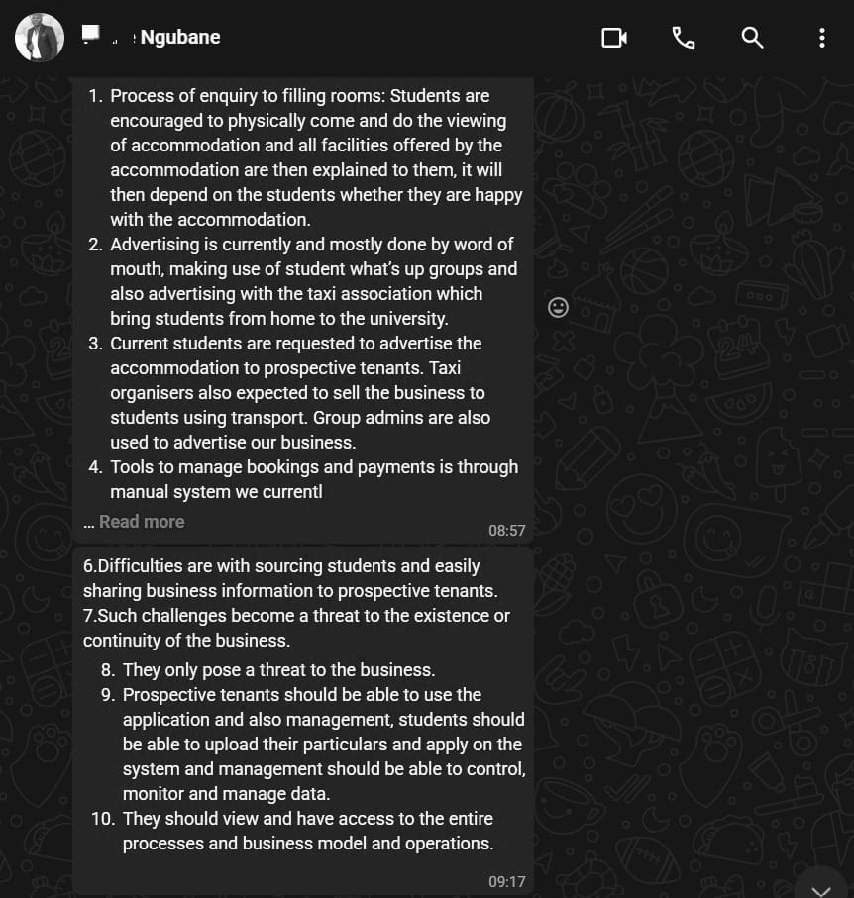
Figure 3 Time meeting started and where it was held
Figure 4 Continuation of questions answered in text
Figure 5 Interview questions answered in text

